Portsmouth Safeguarding Adults Board
Annual Report

2019 - 2020

Statement from the Independent Chair
I am pleased to be able to introduce the Portsmouth Safeguarding Adults Board’s Annual Report for 2019-20.
I was appointed to the role of Independent Chair in the Autumn of 2019. My background is as a registered social worker with a keen interest in effective leadership particularly in public services and especially in safeguarding contexts. I am passionately committed to improving outcomes for vulnerable adults who need safeguarding and I hope to encourage all agencies in the city with responsibility for safeguarding to focus on outcomes relentlessly.
I have noticed excellent working relations in the city between all of the partner agencies and there is obviously a deep commitment to helping those people who need safeguarding. The Portsmouth Safeguarding Adults Board (PSAB) brings those people together regularly to coordinate safeguarding activity. The Board has been working on key priorities (mentioned later in this report) during the last two years or so and making progress. But a new more ambitious strategy is necessary to achieve key outcomes. This process was started towards the end of 2019-2020 and will continue through the next year. I hope to be able to present a new Strategic Plan by March 2021.
During 2019-20 the Board published one Safeguarding Adults Review into the circumstances leading to the emergency admission into hospital of Mr D. Lessons have been learned from those circumstances one of which was the need to improve the way vulnerable young people are supported through the transition into adulthood, which for some involves significant changes in service provision. I am pleased to report that a new Transition Policy and associated procedures have been developed. We looked forward to testing the effectiveness of that new policy and procedure in the coming months.
The 23rd March 2020 will be forever etched as an historical moment of considerable importance; the day the UK went into lockdown to help prevent further Covid 19 infections. Safeguarding services across the City had to change rapidly and it is likely those services will continue to be affected for months and years to come.
David Goosey, Independent Chair

Our vision
"Working throughout the city with our communities and other partnerships to make Portsmouth a city where adults at risk of harm are safe and empowered to make their own decisions and where safeguarding is everyone's business."
Our strategic priorities
During 2019-20 the Board worked on its business plan for the first of a three year planning cycle. The same strategic priorities will continue for the Board's work in 2020-21, with the new Independent Chair leading on a full review of priorities during the year. The Board's strategic planning is firmly underpinned by a multi-agency assessment of key risks to keeping people safe across the City.
All work will be underpinned by the principles of 'Making Safeguarding Personal' (MSP), an approach which enables safeguarding to be done with, not to, people – ‘no decision about me, without me’. MSP principles ensure that safeguarding is person-centred and outcome focused.
Priority 1: Improve practice in relation to the Mental Capacity Act (MCA) and Deprivation of Liberty Safeguards (DoLS)
Adults at risk are empowered to make decisions where they have the mental capacity to do so. Adults at risk who do not have mental capacity are supported to ensure decisions are made in their best interests and that legal safeguards are in place.
The PSAB asked partners to carry out a self audit of their MCA work, which provided assurance to the Board in many areas. However, there is still work to be done around understanding, compliance and training on MCA.
Partners were also asked to identify action plans following their self audits. Following these audits, the 4LSAB (4 Local Safeguarding Adults Boards) Quality Assurance subgroup made several recommendations, including promoting the Hampshire MCA toolkit and a new national e-learning package. A new working group has been set up across the 4 areas to work on the implementation of the new Liberty Protection Safeguards and this group will also consider MCA practice.
The work undertaken by PHT to improve MCA practice, and the support offered by the PSAB and PSCP in 2018-19 through the Safeguarding Improvement Board have led to significant improvements in MCA and DoLS practice which have been confirmed by the CQC inspection report, published in January 2020.
Priority 2: Increase the number of care providers rated good or outstanding by CQC
Service users experience high quality and safe care in all care settings in Portsmouth.
The work of the joint Portsmouth City Council (PCC) and Portsmouth Clinical Commissioning Group (PCCG) Quality Improvement Team is now embedded. The joint Quality Improvement Board carries out detailed monitoring of the work on this priority using a newly developed quality dashboard. The work of this team has included supporting care homes with a quality audit process, which led to a ratings increase from 'Requires Improvement' to 'Good' for three of the homes involved. The team has also set up a City-wide activities coordinator network, and is developing 'Champions Forums' in different specialist areas, such as infection prevention and control. The PSAB receives regular reports and information about care provision in the City from the Quality Improvement Team, Adult Social Care, and CQC.
Priority 3: Pan-Hampshire working
Adults at risk will experience a consistency of approach across all agencies working in Portsmouth, Southampton, Hampshire and the Isle of Wight. Additional staff training will improve how adults at risk are identified and supported. Areas we will improve on are:
- supporting the whole family in a joined-up way
- supporting people who self-neglect through hoarding
- early signposting to sources of support for people who are vulnerable
We will also work with partners on a pan-Hampshire basis to:
- reduce fire deaths by supporting adults at risk to improve fire safety
- monitor and learn from deaths, and ensure that any failures in the system are identified and addressed effectively
A key area of 4LSAB work this year has been to review the 4LSAB Multi-Agency Safeguarding Policy and toolkit, which was first published in 2016. This process is close to completion and the policy will be relaunched in 2020-21.
The 4LSAB Fire Safety Development Group launched the new Hoarding protocol at an event hosted by Hampshire Fire and Rescue Service during National Safeguarding Week. They also worked on a new Fire Safety framework for use across the four areas, which is due for launch in 2020-21.
Portsmouth's Trading Standards team worked with the Trading Standards South East and agencies across the 4LSAB area to hold an event for staff during National Safeguarding Week. The event aimed to raise awareness of financial abuse and scams, and asked attendees and organisations to pledge to roll out the 'Friends against Scams' training in their organisation. The work was followed up by the PSAB at its Board meeting in November 2019.
The 4LSAB's Quality Assurance subgroup undertook some work on 'Making Safeguarding Personal' (MSP), identifying learning from Safeguarding Adults Reviews and case audits across the 4LSAB area. A staff survey of practitioners and managers was carried out to review their understanding of MSP, and any barriers they were experiencing in implementing it. This was followed up with a workshop to look at next steps and develop an action plan.
The Hampshire SAB's Housing subgroup was extended to become a 4LSAB subgroup and now has representation from Portsmouth.

Priority 4: Improve the quality of transition
Service users moving between Children's Services and Adult Services receive timely, effective and coordinated support to help them stay safe and plan for adulthood.
Families are supported in a holistic and joined-up way by all professionals.
The PSAB and Portsmouth Safeguarding Children Partnership (PSCP) have worked with the other Safeguarding Adults Boards and Safeguarding Children Partnerships in Hampshire, Southampton and the Isle of Wight to develop a 'Family Approach' protocol and supporting toolkit. The 'Family Approach' aims to secure better outcomes for children, adults with care and support needs, and their families by co-ordinating the support they receive. The PSAB and PSCP delivered two multi-agency training sessions on this in September 2019, and a further session was put on in December 2019 following demand from staff.
PCC's Children and Families Services, in partnership with adult services in the council, Solent NHS Trust and the voluntary sector, has developed a Family Safeguarding Model to improve the safeguarding of children further and to improve outcomes for adults.
In September 2019, the PSAB and PSCP hosted a joint event on Adverse Childhood Experiences {'ACES'). This was supported by the Office of the Police and Crime Commissioner and delivered by CIS'ters, a local charity which supports women who were sexually abused as children. The event was well attended by staff from many agencies, and aimed to develop their understanding of the science behind ACEs, trauma-informed practice, and the importance of taking a family approach.
Agencies have been updating their transition policies in response to learning from the Mr D Safeguarding Adults Review and this work has been overseen by the PSAB SAR subgroup.
Priority 5: Ensure PSAB decision making is underpinned by robust data
Service users and carers are assured that Board priorities and plans are shaped by evidence, and that resources are allocated where they are most needed.
The Board now receives regular data at each meeting from the Adult Multi-Agency Safeguarding Hub (MASH), Hampshire Constabulary, and Hampshire Fire and Rescue Service, and a 4LSAB dataset has been adopted, which will enable the collection of data from other organisations including NHS Trusts in the coming year. The data from the Adult MASH is also supplemented by an audit of referrals for one week each quarter, which provides a more detailed understanding of what actions other than safeguarding enquiries have been taken.
Where themes have been identified where more work is needed, we have sought bespoke data to help understand the issues. For example Public Health has provided information on substance misuse in the City, and SCAS has provided data on concerns relating to homeless people.
There is still more work to be done to understand the data in more detail and use it to inform our strategy. A particular focus for next year will be on data to help us understand outcomes for service users.
Priority 6: Improve safeguarding adults practice within Portsmouth
Adults at risk will receive a high quality response if referred to safeguarding services, in line with 'Making Safeguarding Personal' principles. If they do not meet the threshold for safeguarding, agencies will work together effectively to ensure that risks are documented and managed.
At 4LSAB level, the Workforce Development subgroup has reviewed the multi-agency Learning and Development strategy, which is designed to support the development of best practice in adult safeguarding work. The Workforce Development subgroup identified self-neglect as a key priority for staff development, and developed a toolkit and learning briefing for staff on the subject.
The Portsmouth Adult MASH developed a new referral form for safeguarding concerns, designed to guide professionals through the process of making a safeguarding referral, improve the information provided in referrals, and ensure that the referrer speaks to the adult and gains their consent before making the referral. With the support of the PSAB, the MASH team hosted several 'Meet the MASH' training sessions aimed at key groups of staff, They also revised their report template to assist those completing s42 safeguarding enquiries to do so according to best practice.
Priority 7: Develop engagement with service users, carers and the public
Service users, carers and the public understand that safeguarding is everybody's business. They have access to information about safeguarding, including how to raise a concern and how to keep safe. There are mechanisms for service users, carers and the public to engage with the Board.
Jointly with the other three LSABs, the Board commissioned an 'animation scribe' video to help explain to service users and the public what safeguarding is and the process of raising a concern. This was launched during National Safeguarding Week and used as a basis for a social media campaign on key safeguarding themes. The video can be accessed on the 'Portsmouth Safeguarding Adults Board' YouTube channel.

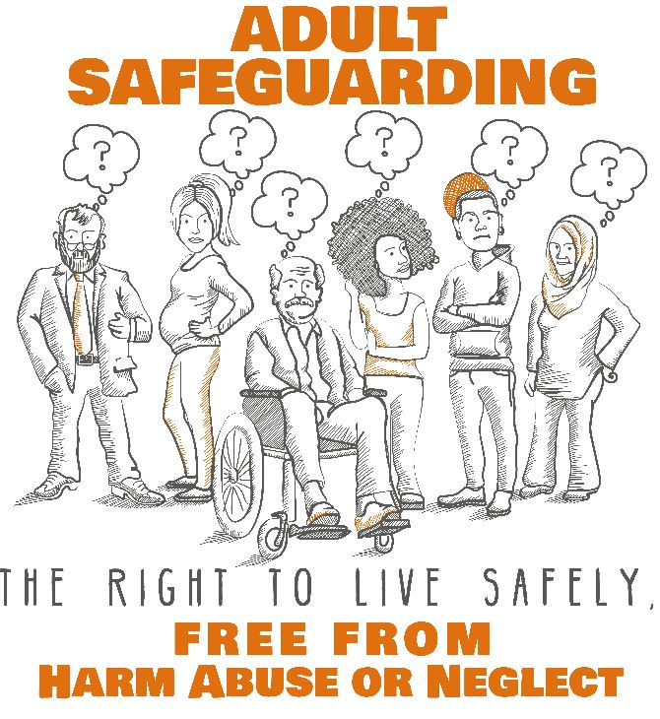
This year we reviewed our website, taking into account feedback from our partners. We also commissioned our website provider to review the accessibility of our website, to make sure it meets the new requirements.
As part of National Safeguarding Week 2019, Portsmouth Hospitals Trust organised a Domestic Abuse information stand in the foyer at Queen Alexandra Hospital. Members of the public, service users and carers (as well as staff) had the chance to meet different service providers in the City and the Safeguarding Adults Board team. Over 100 people engaged with us during the day.
Learning from Safeguarding Adults Reviews
The Care Act 2014 states that a Safeguarding Adults Review (SAR) must take place when:
"there is reasonable cause for concern about how the Safeguarding Adults Board, members of it or others worked together to safeguard the adult, and death or serious harm arose from actual or suspected abuse".
The PSAB has a SAR subgroup which is chaired by the Director of Quality and Safeguarding from NHS Portsmouth Clinical Commissioning Group. The group is a multi-agency group with members who have a specialist role or experience in safeguarding adults. The group met monthly during 2019-20 and part of each meeting was conducted jointly with the Portsmouth Safeguarding Children Partnership’s (PSCP) Learning from Cases Committee (LfC), working together on cases which might involve both children's and adult services.
Publication of 'Mr D' SAR
In May 2019, the PSAB published the 'Mr D' SAR, which reviewed the circumstances that led to Mr D's emergency admission to hospital in September 2017 with a grade 4 pressure sore and osteomyelitis. Mr D was a young adult with a learning disability who had previously been in the care of the local authority. The review was undertaken by an Independent Author and overseen by a review panel. The recommendations from the review were as follows:
- That the Board, together with the Portsmouth Safeguarding Children’s Board (PSCB), seek assurance from Adult Social Care and Children's Social Care that they have reviewed and revised as appropriate the Transition Process from Children’s to Adult Services, with a particular focus on Looked After Children and Care Leavers, including ensuring their staff have a proportionate knowledge of the relevant social care legislation and practice.
- That the Board seek assurance from the PSCB that it monitors its partner agencies’ implementation of the Mental Capacity Act 2005 in their involvement with parents and carers.
- That the Board seek assurance that the local authority’s Legal Services have reviewed and revised as appropriate its procedures and practice for advising both Children's and Adult Services on the implications of the Mental Capacity Act 2005 for their young people transitioning from Children’s to Adults’ Services.
- That the Board seek assurance from the PSCB that its member agencies are ensuring parents and carers are challenged appropriately if they do not cooperate with agreed Care Plans, with a particular focus on children in transition to Adults' Services.
- That the Board seek assurance from PSCB and its own member agencies that they monitor Supervision Procedures and Practice to ensure that staff are supported to develop professional working relationships and encouraged to show ‘professional curiosity’.
- That the Board seek assurance from partner agencies that they and the services they commission, have appropriate systems and processes in place to ensure the effective implementation of the Mental Capacity Act 2005 and its supporting Code of Practice, in particular in respect of Unwise Decisions.
- That the Board seek assurance from Children's Social Care that it has reviewed and revised the Looked After Children Review process to ensure it is fit for purpose and that independent Advocates are used to ensure that those children who may have difficulty participating in the Reviews are enabled to do so effectively.
- That the Board seek assurance from partner agencies that they, and the services they commission, have appropriate process and systems in place to monitor adults with care and support needs who make frequent use of their emergency and out-of-hours services.
- That the Board seek assurance from Adult Social Care that it has reviewed and revised as appropriate its policies and procedures for the provision of assessments and implementation of Care Plans to ensure that they are compliant with the Care Act 2014 and its supporting Statutory Guidance, with particular reference to the provision of Independent Advocates and those who do not engage with services.
- That the Board seek assurance from partner agencies that they and those services they commission have reviewed and revised as appropriate, their 'did not attend' (DNA) policies and procedures.
- That the Board seek assurance from partner agencies that they have reviewed the processes by which consideration is given as to whether there are grounds for a formal investigation into whether any offences have been committed under s44 of the Mental Capacity Act 2005.
- That the Board seek assurance from partner members that they, and the services they commission, ensure that assessments are holistic and multi-agency and that staff are encouraged to demonstrate ‘professional curiosity’ to look beyond the ‘presenting issue’.
- That the Board seek assurance from the Health and Wellbeing Board that services are being developed to ensure that they are accessible to all, including those who are obese.
- That the Board seek assurance from the Queen Alexandra Hospital that they have reviewed and revised as appropriate their Discharge policies and procedures to ensure that adults with additional care and support needs are discharged safely into the community.
- That the Board seek assurance from partner members but from Adult Social Care in particular that they have reviewed and revised as appropriate their policies and practice re communicating with adults with learning disabilities and/or communication difficulties.
- That the Board seek assurance from partner agencies that they and the services they commission have in place effective staff development and monitoring processes to ensure that staff know when and how to raise safeguarding concerns with the local authority.
- That the Board seek assurance that the Adult Multi-Agency Safeguarding Hub has reviewed and revised as appropriate its Policies and Procedures for triaging safeguarding concerns to ensure proportionate responses in accordance with the principles of Making Safeguarding Personal.
- That the Board seek assurance from the Health and Wellbeing Board that the lessons identified in recent research into the health outcomes for adults with a learning disability have been recognised and addressed locally by both health and social care agencies, including the development and implementation of Health Action Plans
The Independent Author's recommendations were accepted in full by the PSAB and a multi-agency action plan was developed to address them.
Similar themes were identified to a learning review ('Child G') being conducted by the PSCP at the same time. These included:
- transition
- mental capacity and consent
- family engagement
- escalation
- honest conversations and professional curiosity
Given that many of the agencies involved were the same and there were overlaps between the workforces, it was decided to publish the reviews together and to combine and monitor the action plans jointly.
The PSAB and PSCP jointly held nine multi-agency training sessions in May/June 2019, reaching 237 staff to share the learning from the cases. Three of these sessions were held at Queen Alexandra Hospital. Staff were asked to commit to making changes to their practice based on their learning and this was followed up with a sample of attendees. Learning from the reviews has also subsequently been embedded in routine training opportunities for staff, for example via the regular briefings held by the Principal Social Worker. The Board Manager also delivered a training session to Hampshire-based staff, to share the learning across the wider health and care system.
A member of staff from Portsmouth Hospitals Trust created these 'visual minutes' to sum up the learning from the training event she attended.
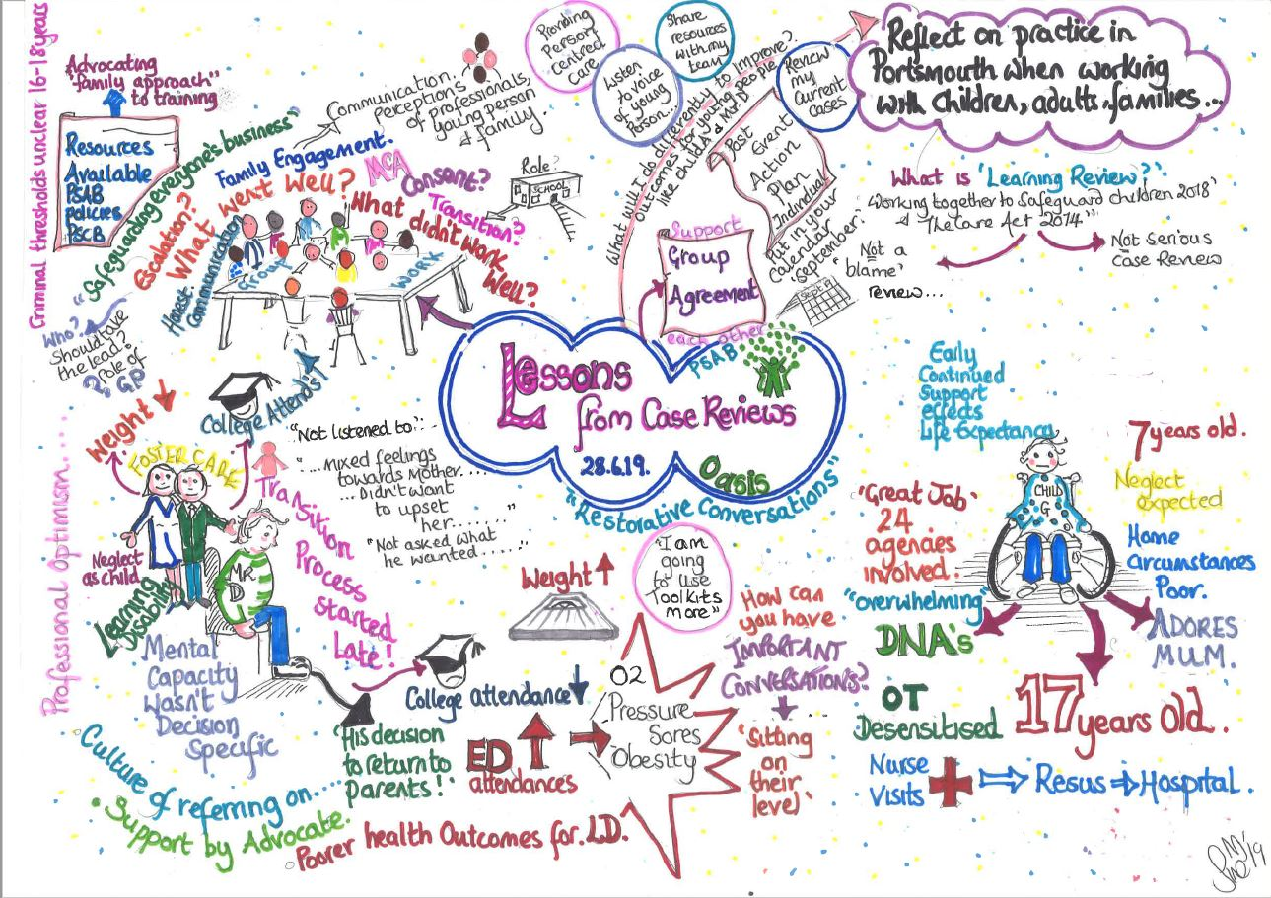
The multi-agency action plan is closely monitored by the SAR/LfC joint subgroup and agencies are asked to submit updates on a bi-monthly basis. Actions are reviewed by this group and closed once the group is confident that the action has been completed. The actions identified by individual agencies in their Individual Management Reviews are also being monitored in the combined action plan. Where relevant, partner organisations have been asked to give assurance that their systems, processes or practice have been reviewed in light of the findings of the reviews, and their responses and resulting action plans are also scrutinised by the joint subgroup.
Some of the actions taken to address the SAR recommendations include:
- Development and promotion of the 'Family Approach' protocol and supporting toolkit (see above).
- All GP practices in Portsmouth were asked to review their systems and processes to monitor adults with care and support needs who make frequent use of emergency services. This led to a new policy for best practice for adults with learning disabilities at one practice; and new processes to automatically identify such cases being introduced at several practices.
- Adult Social Care, Children and Families, PHT and Solent NHS Trust have all undertaken work to improve supervision. Audits have been carried out to check that changes have been implemented.
- Adult Social Care and Children and Families have been working together to review their transition policy to incorporate the learning from Child G and Mr D. This revision of the policy is being overseen by the SEND (Special Educational Needs and Disability) 'Preparing for Adulthood' group and has also included consultation with young people and their families through the SEND Board. The PSAB and PSCP are due to conduct a joint piece of work to quality-assure transition work in 2020-21.
The Mr D SAR summary report and a learning briefing are available to read in full on the PSAB website at portsmouthsab.uk/scrs-2/.
Summary of SAR activity during 2019-20
Two SAR referrals were carried forward from 2018-19. Neither referral was found to have met the statutory criteria for a mandatory SAR, and in one case, following scoping, there was no learning identified.
In the other case it was identified that there may be learning for substance misuse services within the city for cases when a client is discharged following detoxification treatment. A learning event was therefore held with all the agencies involved in the case to explore this issue further. This event identified a range of good practice, including a wide range of high quality support and information provided by specialist drug services, the GP, the community and peers. Practitioners knew the person well and were able to offer him individual and tailored support. There were two areas identified where things could have been done differently, but it was unlikely to have changed the outcome. In future cases, opioid blockers will be explored, and alcohol services will liaise with mental health services at the point of discharge if required.
Fourteen new SAR referrals were received in 2019-20.
One referral met the statutory criteria for a mandatory SAR and a SAR has therefore been commissioned which will take place in 2020-21. A SAR panel has been convened, Terms of Reference drafted, and expressions of interest have been sought from independent authors.
For three cases, further scoping information has been requested from organisations involved, and a decision will be made in 2020-21 as to whether the cases meet the SAR criteria.
Nine of the referrals were scoped and reviewed by the SAR subgroup but were not found to have met the statutory criteria for a mandatory SAR. In one case a learning event was held, led by Public Health. One was reviewed as part of the Learning Disabilities Mortality Review (LeDeR) programme and, while there was learning for one organisation which put in place an action plan, there were no multi-agency concerns. Another identified no learning for Portsmouth organisations, but the case was passed to Hampshire SAB, as the person came from their area and it was considered there may be learning for their members.
Following the work on these cases, learning was identified and recommendations made to individual agencies and PSAB.
Some of the actions taken or planned in response include:
- A task-and-finish group has been convened to ensure that the Multi-Agency Risk Management Framework is embedded in the culture and practice of all organisations. The PSAB has also commissioned training on this for 2020-21.
- Member organisations were asked to provide the PSAB with assurance that the 4LSAB Escalation Protocol was embedded within their organisation and that it was being used appropriately.
- Staff and residents in premises where there is a higher risk of drug overdoses will receive training on overdose prevention.
- Homeless supported housing commissioning is under review.
In a further case, it was decided that it would be beneficial to hold a discretionary multi-agency learning review, despite the case not meeting the criteria for a mandatory SAR. This is planned for 2020-21.
A number of the cases referred in 2019-20 involved housing and substance misuse services, so attendees from Housing and Public Health were invited when required. The subgroup received presentations on drugs and alcohol misuse, and services for homeless people. The subgroup's membership has now been expanded to include a member from Housing. In 2020-21 the PSAB will take part in a project led by the charity Alcohol Change UK to address safeguarding of vulnerable change-resistant drinkers.
In 2018-19, the SAR subgroup introduced a process to identify deaths of people who had been rough sleeping. While there were no deaths identified in 2019-20 of people who were currently rough sleeping, the process did identify four deaths of people who were homeless and housed in temporary accommodation. SAR referrals were made for all these cases, and, while none met the criteria for a mandatory SAR insofar as the deaths were not deemed to have resulted from abuse or neglect, learning was identified and some changes made to services in response. One example is the 'Towards Better Health' project. Set up in February 2020 with funding secured by Public Health, it aims to bring health services including GPs, and physical and mental health nurses closer to people at risk of rough sleeping, by conducting weekly surgeries, drop-ins and in-reach in the homeless day centre and main homeless hostel. A member of the MASH team now also provides specific support to homeless services on safeguarding matters.
The 4LSAB Fire Safety Development Group also looks at all fire deaths in the 4LSAB area, to identify learning applicable to all areas. In 2019-20, one Portsmouth case was considered by this group and it was also referred to the SAR subgroup.
2019-20 has seen a higher than usual number of referrals. As most of these have not met the statutory criteria for a mandatory SAR, it is likely that this increase reflects the work of the Board in promoting the SAR referral process, including through the publication of the Mr D SAR and associated training, rather than underlying issues with services. The increased number of referrals has been helpful in identifying learning and themes for further work.

Safeguarding Activity in Portsmouth
Safeguarding Duty
Under Section 42 of the Care Act, a local authority has a duty to make enquiries or cause others to make enquiries in cases where it has reasonable cause to suspect:
- that an adult has needs for care and support (whether or not the local authority is meeting any of those needs) and
- is experiencing, or at risk of, abuse or neglect and
- as a result of those care and support needs, is unable to protect themselves from either the risk of, or experience of, abuse or neglect.
Portsmouth has an Adult Multi-Agency Safeguarding Hub (MASH) with a team of social workers and police officers working together who have direct links with colleagues in areas such as health, trading standards and children's safeguarding. The MASH manages a high volume of referrals.
Data collected by the MASH gives further information about who has experienced abuse or neglect in Portsmouth, where abuse has taken place, and the types of risk they have experienced. The information below is taken from the NHS Digital Safeguarding Adults Collection end of year return.
If an issue about an adult safety or welfare is raised with the MASH, this is categorized as a Safeguarding Concern. The MASH will then assess the concern and take appropriate action.
There were 2,224 concerns raised in 2019-20 about 1,497 individuals.
More information about the individuals involved in safeguarding concerns is shown below.
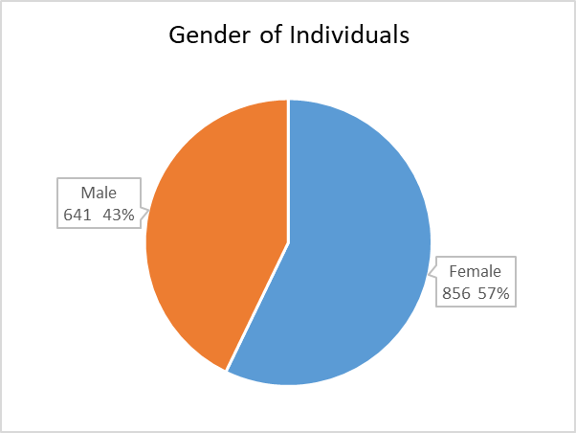
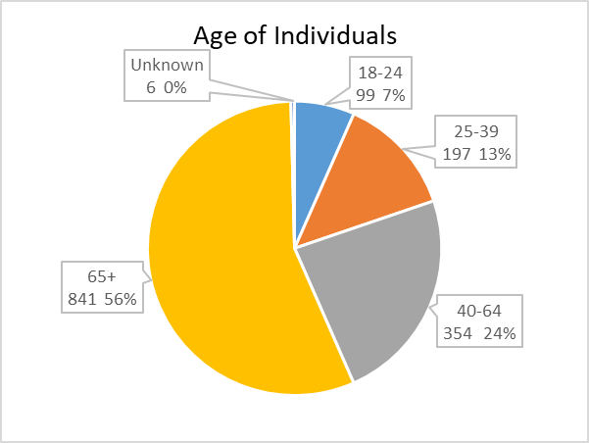

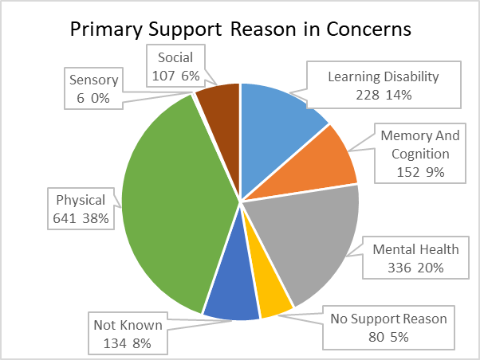

294 safeguarding concerns were taken forward as formal Safeguarding Enquiries under Section 42 of the Care Act.

The Board also receives data regularly from Hampshire Constabulary and Hampshire Fire and Rescue Service.
In 2019-20 Hampshire Constabulary reported:
- 10 incidents of Honour Based Violence where the victim was over 18.
- three incidents of trafficking of a person over 18.
- 798 high risk domestic crimes
- 607 incidents of hate crime
HFRS carried out 1032 Safe and Well visits in Portsmouth in 2019-20.
There was 1 domestic homicide in Portsmouth in 2019-20.
There was 1 fire death in Portsmouth in 2019-20.

Contact us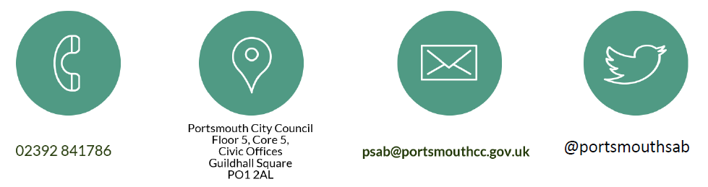

Glossary

4LSAB - The Portsmouth, Southampton, Hampshire and Isle of Wight Safeguarding Adults Boards.
4LSCP - The Portsmouth, Southampton, Hampshire and Isle of Wight Safeguarding Children Partnerships.
CCG - Clinical Commissioning Group. They are clinically-led statutory NHS bodies responsible for the planning and commissioning of health care services for their local area.
CQC - Care Quality Commission. The independent regulator of all health and social care services in England.
DoLs - Deprivation of Liberty Safeguards. Part of the Mental Capacity Act 2005. A set of checks that aims to make sure that any care that restricts a person’s liberty is both appropriate and in their best interests.
HFRS - Hampshire Fire and Rescue Service.
LeDeR - Learning Disabilities Mortality Review programme. A national programme funded by the NHS to review the deaths of people with a learning disability. It aims to reduce premature deaths and health inequalities for people with learning disabilities.
LfC - Learning from Cases Committee (a committee of the Portsmouth Safeguarding Children Partnership, which also meets jointly with the Safeguarding Adults Review subgroup of the Portsmouth Safeguarding Adults Board).
LSAB - Local Safeguarding Adults Board.
MASH - Adult Multi-Agency Safeguarding Hub. A multi-agency team including social workers and police officers which is the first point of contact for adult safeguarding concerns.
MCA - Mental Capacity Act 2005. The Act is in place to protect and empower people who may lack the mental capacity to make their own decisions about their care and treatment.
MSP - Making Safeguarding Personal. A personalised approach that enables safeguarding to be done with, not to, people.
NHS - National Health Service.
PHT - Portsmouth Hospitals NHS Trust. A large district general hospital providing comprehensive acute and specialist services. The main site is Queen Alexandra Hospital in Portsmouth.
PSAB - Portsmouth Safeguarding Adults Board. A multi-agency partnership which oversees and coordinates work to keep adults at risk safe in Portsmouth.
PSCP - Portsmouth Safeguarding Children Partnership. A partnership which brings together all the main organisations who work with children and families in Portsmouth, with the aim of ensuring that they work together effectively to keep children safe. (Formerly known as the PSCB - Portsmouth Safeguarding Children Partnership.)
SAB - Safeguarding Adults Board.
SAR - Safeguarding Adults Review. A multi-agency review process which Safeguarding Adults Boards must carry out to identify learning when an adult at risk dies or is seriously harmed as a result of abuse or neglect, and there are concerns about the way in which organisations worked together to safeguard the adult.
SCAS - South Central Ambulance Service NHS Foundation Trust.
SEND - Special Educational Needs and Disability

Appendix

What is Safeguarding?
“Safeguarding means protecting an adult’s right to live in safety, free from abuse and neglect. It is about people and organisations working together to prevent and stop both the risks and experience of abuse or neglect, while at the time making sure that the adult’s wellbeing is promoted including, where appropriate, having regard to their views, wishes, feelings and beliefs in deciding on any action.” (Care Act 2014)
Who are we?
The Portsmouth Safeguarding Adults Board (PSAB) is a partnership of key organisations in Portsmouth who work together to keep adults safe from abuse and neglect. These include:
- Adult social care
- Health
- Emergency services
- Probation services
- Housing
- Community organisations
The Board has an independent chair that can provide some independence from the local authority and other partners. This is especially important in terms of:
- offering constructive challenge
- holding member agencies to account
- acting as a spokesperson for the PSAB.
The Board is funded through contributions from its statutory partners (Portsmouth City Council, NHS Portsmouth Clinical Commissioning Group and Hampshire Constabulary). The agreed contributions are:

The structure of our Board and its subgroups is shown in the diagram below. In the areas of Policy Implementation, Workforce Development, Quality Assurance and Housing, we have shared '4LSAB' working groups with the neighbouring Boards (Hampshire, Southampton and the Isle of Wight). This helps ensure we work in a joined-up and coordinated way with our partners across the region on common priorities.

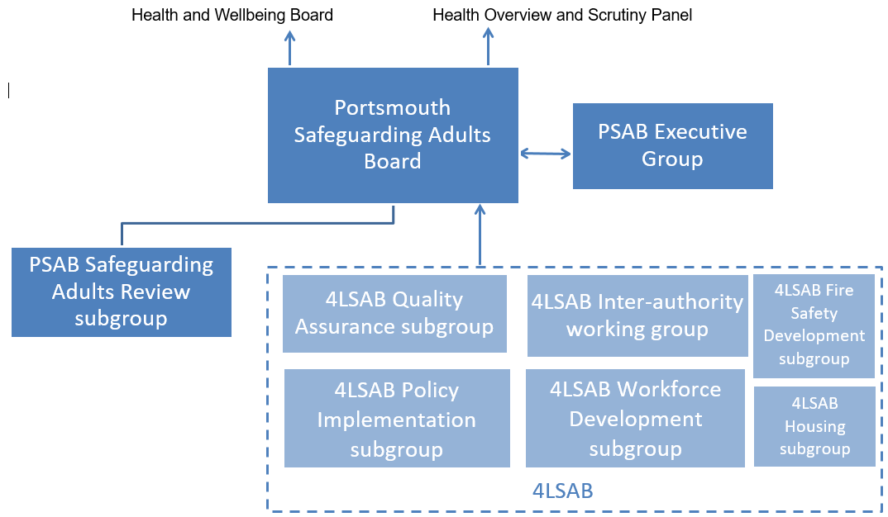

A glossary of terms and acronyms is available on page 15 of this annual report

