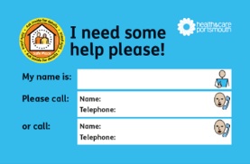 | If you want your own Safe Places card, please email: safeplaces@portsmouthcc.gov.uk  Any adult over 18 who wants to can carry a card.
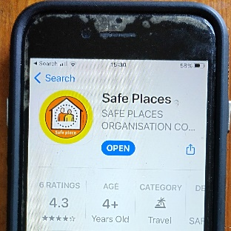 | If you have a smartphone you can download the free Safe Places app.  The app will show you on a map where the nearest open Safe Place is.
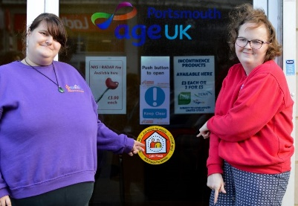 | All Safe Places have this sticker in their window.
Portsmouth Safe Places

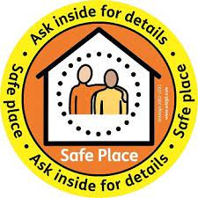

 | Do you sometimes feel worried or unsafe when you are out in Portsmouth?
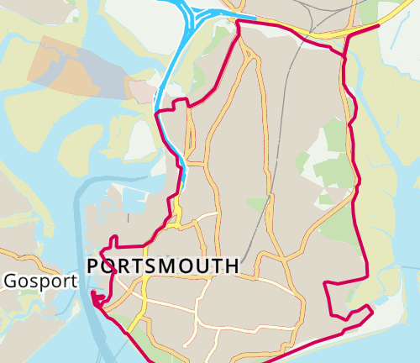 | There are now some Safe Places around Portsmouth to help you.
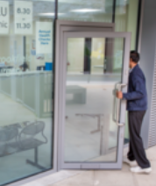 | You can go to a Safe Place if you are lost, worried or need help.
 | When you go into a Safe Place, tell a member of staff that you need help.
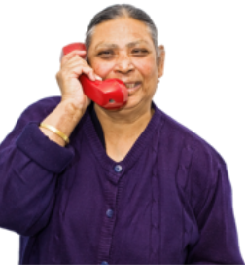 | They will help you and will telephone a friend or family member if you want them to.

