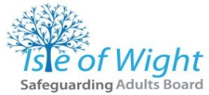
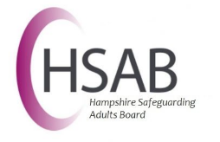

AGENDA

Multi-Agency Risk Management Meeting

Date
Time
Location

This meeting is being held under the umbrella of the 4LSAB Multi-Agency Risk Management Framework. This process has been endorsed by the partner agencies of all the Local Safeguarding Adults Boards in Hampshire, Isle of Wight, Portsmouth and Southampton and has been incorporated into each agency’s standard operating procedures. For more information, please refer to the 4LSAB Multi-Agency Risk Management Framework
Timely and appropriate information sharing is at the core of this process and professionals need to refer both to the 4LSAB Information Sharing Framework as well as their own agency’s information governance policies and guidance.
There may be occasions when there are differing perspectives and judgements amongst professionals. When disagreements cannot be resolved, professionals should refer to the 4LSAB Escalation Protocol.
The 6 Principles of adult safeguarding should be promoted throughout the Multi-Agency Risk Management Process by all participants irrespective of which agency is leading and coordinating the process.

All information shared at this meeting is confidential and privileged and is not shared outside of this meeting without the permission of the chair and the agency that provided the information.
Chair
Organisation
Role

- Introduction
Chair’s Welcome
Introductions
Apologies
- Current situation
Summary of any care and support offered or in place
Individual agency perspectives of the concerns and risks to the adult/others
The individual’s views and wishes and how they wish to be involved
The individual’s strengths and assets including family and wider social network
- Mental Capacity
Consideration of the individual’s mental capacity around the areas of unmanaged risk
- Assessment of risk
Collaborative and holistic assessment of presenting risks
- Discussion
Legal powers and remedies in use or potentially available
Rationale for using/not using powers and remedies available
Lead coordinating agency for the process
Individual named workers for each agency
Information sharing arrangements (with the adult’s permission, where possible)
Contingency and escalation plan
- Shared risk management plan
Risk management plan
Confirm who will share the plan with the individual
How the individual will be involved and kept up to date
Monitoring and review arrangements

